Joint Types
Framing Joints
Framing joints, as their name suggests are used for jointing framing members together and range in strength and complexity from a simple butt joint to a scribed/mitred joint.
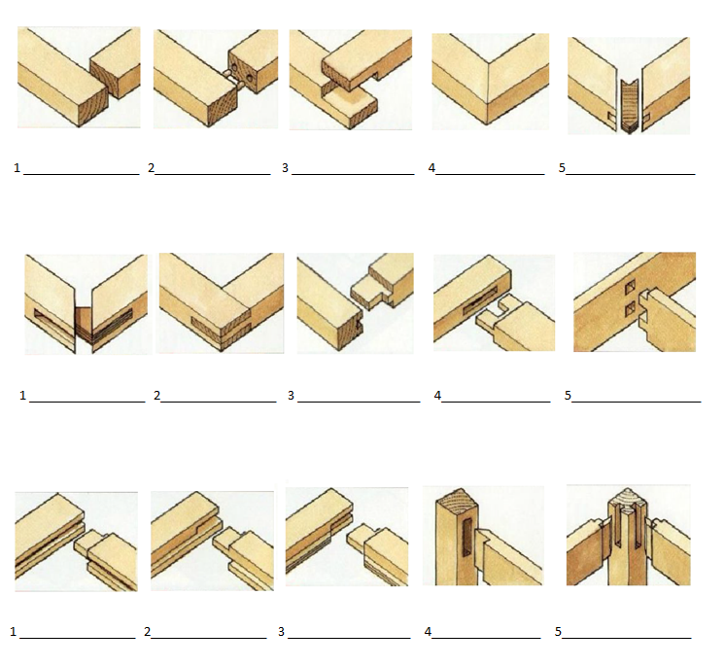

Board Edge Joints
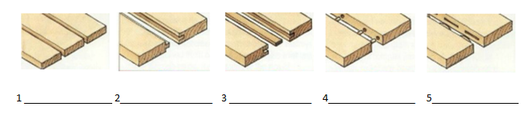
Used for edge jointing boards together to form wide boards.

Box/Board End Joints
Used for connecting wide boards to form boxes/carcasses. These too range in complexity from the butt joint to ornate dovetails.
