



Technological University Dublin
College of Engineering and Built Environment
School of Architecture, Building and The Environment
Discipline of Construction
Wood Manufacturing & Finishing

Course Code: B115
Student Name:
Student ID Number:
Academic Year: 2025/26
Term: 3
Title:

I declare that the work contained in this submission is my own work and has not been taken from the work of others save to the extent that such work has been cited within the text of this submission.
Student Signature: __________________
Date: 04/04/2026 Word Count:
Table of Contents
Introduction 3
History of Circular Saws 3
Circular Saw Types 3
Handheld Circular Saw 3
Radial Arm Saw 3
Up-Cut Saw 3
Panel Saw 3
Mitre Saw 3
Types of Blades 3
Types of Teeth 3
Regulations 5
Conclusions 5
Reference Page 7

(The table of contents above illustrates the various heading styles: Heading 1, Heading 2, Heading 3). See the sections below.

Start to type in your headings remember to choose the correct heading style then update the table of contents and see what happens.

Break the assignment into various sections in the most appropriate manor to suit your topic. The following section illustrates this, note the use of headings and sub-headings.
Note that Fonts style/size is Calibri 12, text is justified with a line spacing of 1.5. Keep the labels the same eg. Fig. 1., Fig. 2, Fig. 3, etc. not Fig. 1, Figure 2., fig 3.

Introduction
Who are you? What have you been asked to do? What is your topic? What are you going to look at? Where are you going to carry out your research? Fo example …. In this report I am going to research the following……. I will carry out this research by looking at ……..

History of Circular Saws
This may not be applicable to your topic, but for example if your topic is a machine look at the evolution of that machine, discuss the evolution of this machine as we now know them. What has changed.

Circular Saw Types

Handheld Circular Saw

Radial Arm Saw

Up-Cut Saw

Panel Saw

Mitre Saw

Types of Blades

Types of Teeth

Do not forget to include 5 images that are referred to within the text, numbered, labelled and referenced. Ensure you select good quality images and make sure you do not distort them.
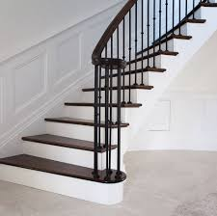
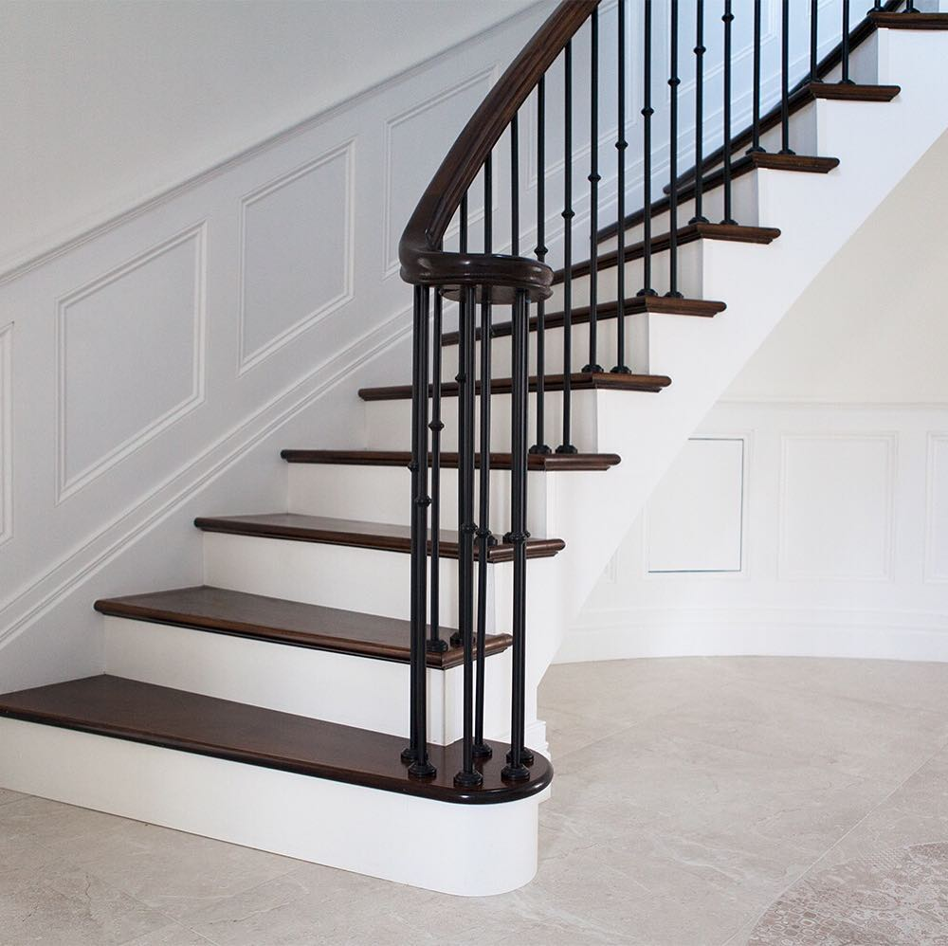
Fig. 1 Stairs showing spindle and handrail.
Image obtained from McNally Joinery
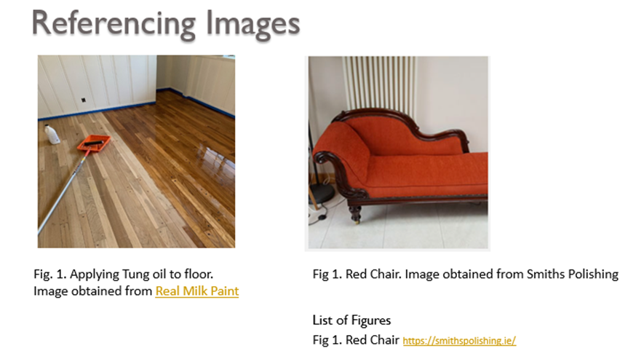
(Put in link to image in the image list or reference list Source: https://www.facebook.com/mcnallyjoinery)
Keep the images within the margins of the page and in line with the text, remember to make image Square this will allow you to move easily on the page. Number each image or sketch Fig. 1,Fig. 2 etc. label them (say what is in the image) watch capital letters starting the label and say where you obtained them (put ref link into List of Figures either before or after the references.
Look at samples provided to see List of figures and reference page layout at the end of your report. Link your report together by commenting on the images using phrases like as seen in Fig.1 or the legs on the table in Fig. 2 or when referring to something if you compare the machine setup in Fig. 3 to Fig. 4 you can see…….

Regulations
Check and see if there are any Building or Health and Safety Regulations relating to or governing your topic. Refer to Irish regulations, check out Health and Safety Authority
Refer to Woodworking machine regs 2016
https://www.irishstatutebook.ie/eli/2016/si/36/made/en/print

Conclusions
Reflect upon what you have learned from completing this project and how it may or may not impact you in your current place of work. Share anything interesting that you discovered while carrying out this research.
For the conclusion start with:
During my research of ..Your Topic .. I learned…(tell me what did you learn?)
I found.. (What information did you find where did you find it?)
I discovered…( what did you discover did you learn something new),
I was surprised that …..(were you surprised by anything that turned up in your research?)
From carrying out the research has it added anything to your knowledge that can be applied to your current or future work situation?
Finally, did you enjoy this project why or why not?

Reference Page
You will be expected to insert a minimum of five references, illustrating where you have sourced the information for this assignment. If you have used Generative Artificial Intelligence then you must state what tool you used and for what purpose you used it.
Free tool available at mybib.com.
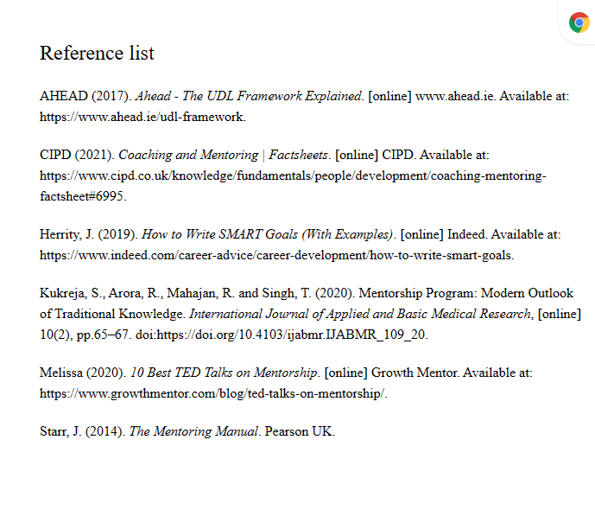
Example Reference list

