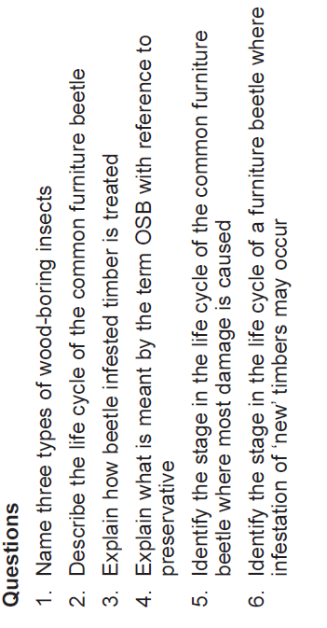
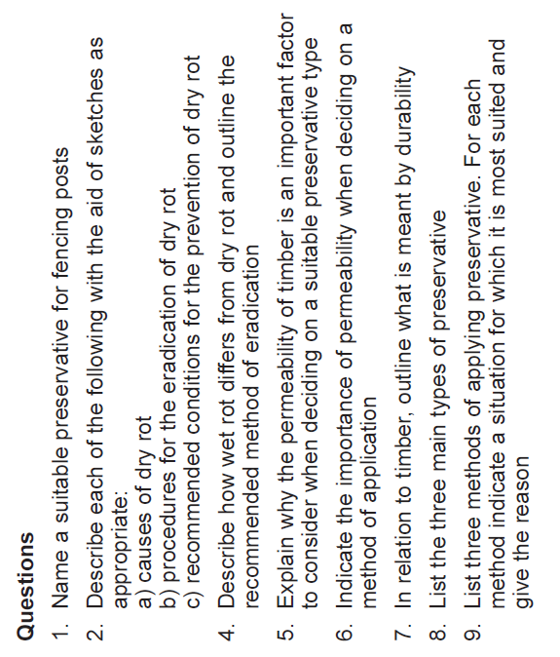

https://youtu.be/KjHB5tzx9fE

Dry Rot an overview from the Dry Rot experts
Timberwise - Property Care Experts (7.19)

https://youtu.be/f59nYVKMMH0
Woodworm identification – 11 types (3.45)

https://youtu.be/Hiw6hqTG610
The life cycle of woodworm (4.26)

https://youtu.be/6E_klB-WLd8

Common wood boring insects - www.damp-proofing-specialists-london.co.uk (18.00)

Start at 16.05

https://youtu.be/f9r6QmgeFE8
Woodworm Information and Advice from the Woodworm Specialists (1.56)

https://youtu.be/ZbOLZbpAIh4
What is Woodworm? Problems and Woodworm Treatment by Protum Services Ireland - Protum.ie (2.10)

